Griffith University
Student World Travel Company
Website plan
1220HSLYuki Miyakita

Abstract:
This is a future plan that to open a travel company. This travel company will make students more familiar with overseas.

Contents
1. Introduction & Background 1
2. Business Goals & Website Goals 1
Business goals 1
Website goals 2
3. Competitor Website Analysis 2
4. Target audience & Forecasted use Environment 3
Target audience 3
Forecasted use environment 3
5. User tasks 4
6. Website Content and Development Tools 4
Website content 4
Development Tools 5
7. Website Content Storyboard 6
8. Website Template Designs 7
9. Process Analysis 8
• Communication 10
• Update 10
10. Marketing Techniques 11
11. Conclusion 12
12. References 13

1. Introduction & Background
Nowadays tourism is one of the most important industries in the world, and many tourism companies such as airlines, hotels, amusement parks, and their travel companies use websites to attract people. These companies gather customers by making their website convenient by showing information about products, discounting, and answering customer's questions. Salehi, Abdollahbeigi, Langroudi, and Salehi (2012) said that “Web site information convenience is an important factor to attract customers and make a connection between them and company's product or services” (p. 382). In addition, customers can see websites anywhere by using a phone and an internet, so websites are an essential factor to success in business.

This business report's idea is to make a travel company which targets students (aged from 15 to 29 which is senior high school to post graduate school student) who live in Japan and Australia, and this company allows students to go abroad more easily. This company's tasks are to get a flight ticket, make a booking of accommodation, and get a visa as required (by the customer). The travel company's name is “Student World Travel Company” (SWTC) which is located in Tokyo and Osaka in Japan, and Gold Coast and Sydney in Australia. Each company has about 20 employees and their executives meeting every two months for a conference (about business). The company will increase employees when my travel company becomes popular. This company's aim is to make the Japan- Australia relationship stronger. Going abroad is one of the most significant factors to make a relationship for every country, and if the number of Japanese and Australian students who go to each country increases, the relationship will be stronger than before. To allow students to go easily to each country, this company will make travel fees cheaper, and increase the number of air flights between Japan and Australia.

2. Business Goals & Website Goals

Business goals
This company's business goals are
・To raise the number of travellers who go between Japan and Australia to 5000 per year.
・ To extend a value of travel commodity to 50 by 2025.
・To rank in the top 3 of the most popular travel companies in Japan and Australia by 2035.

Website goals
Next, this company's website goals are
•To increase people who buy flight ticket to 14 per day.
•To target 150 bookings every day in order to gain 25 membership signup online every day,
• To gather feedback from customers every week to improve bad point.

3. Competitor Website Analysis
 | Strength | weakness
STA Travel | • Easy to search & booking because there is a search box.  • Multiple languages supported.  • Price comparison function available.  • User friendly design of question form.  • High quality images visible in each page. | •Many topics tmake people are puzzled.  • Background is simple.  • Hard to see some page's pictures because pictures are too small.  • Logo is not intelligent.  • Advertisement which is shown on the right side is annoying.
Student Flights  Australia | • Feedback to hear customers' opinion.  • 24 hour customer service available.  •Discount service.  • Movies to make interested people.  • Expectations are shows below when customers write words in the search box. | • Hard to read text because font size is too small.  • Top of pictures are too big.  • Limited destinations.  • Simple background.  • Service corners do not open on  Sundays or public holiday.
Table 1.1 Competitor Website analyses

4. Target audience & Forecasted use Environment

Target audience
This company's main target audience is students, especially 15 -29 (From senior high school to university students who travel each country as an individual traveller, a backpacker, and overseas student), and their country is Japan and Australia. The company will be established in Tokyo, Osaka, Gold Coast, and Sydney. The target of students is individual and group. This company will increase students who go to each country to 5000 per year, and make the Japan-Australia relationship stronger.

Forecasted use environment
Many young people who are type of connectors in online consumers use internet or mobile phones to make bookings recently. Some researchers said that “...we found that most of the users of the Internet for booking online tourism products are young” (Cheung & Law, 2009, Law & Wong, 2003, and Schonland & Williams, 1996, as cited in Besbes, Kucukusta, Law, & Legohérel, 2015). Some research shows that Japanese prefer Yahoo! (49%) to Google (39%) (SEO-ch, n.d.). Global Marketing channel (2012) shows that Australia's most popular search engine is Google (95%). So this company will make my website both Google and Yahoo! friendly in order to increase the number of visitors for my website. Net Market Share (August, 2014 to June, 2015) suggested Internet Explorer is used over 50% in both Japan and Australia, so this company will use Internet Explorer for web browser. During using the website, some issues may occur for example, if the website includes many pictures of movies on the homepage, customers have to download many things and it takes much time. To prevent this problem, the website's pictures and movies to be less cubic content or make a gallery page.

5. User tasks
- User can receive online discount monthly through email.
- User can make online booking of flight from on selected day.
- User can find a shop when they want to ask questions directly such as reservation.
- User can book an accommodation, after when they finished to make a reservation.
- User can compare fares with other travel companies.
- User has offers when they lose luggage.
- User can ask questions through question corner.
- User can have helps when they want to get visa.
- User has an opportunity to send feedback to this company.
- User can get points if they become this company’s membership, and these points can use for shopping and buying tickets.

6. Website Content and Development Tools

Website content
 | Content List
Flight | A flight search box, Compares fares with other companies, payment, application form, description and photos of destination, a translation
Accommodation | Booking form, a searching box, photos of accommodation, map for accommodation, details of each accommodation, payment, a translation
Deals | Description of deals, search flight deals and accommodation, a translation
Visa | Description about process to get visa, application form, payment, a translation
Contact | A question form, Feedback conform, an application form to be membership, sign in to membership, a translation, telephone answering
Table 1.2 Website content lists

Development Tools
- Wix for page creation and design in order to attract customers.
- You-tube for video promotion to show customers information of destinations.
- PayPal for online payment that is easy for customers to buy products.
- Google-Maps to put map into website which make customers easy to find a shop.
- Mailing widgets to send customer new travel information such as discounting.

7. Website Content Storyboard

Figure 1.1 Website content storyboad

8. Website Template Designs
Homepage
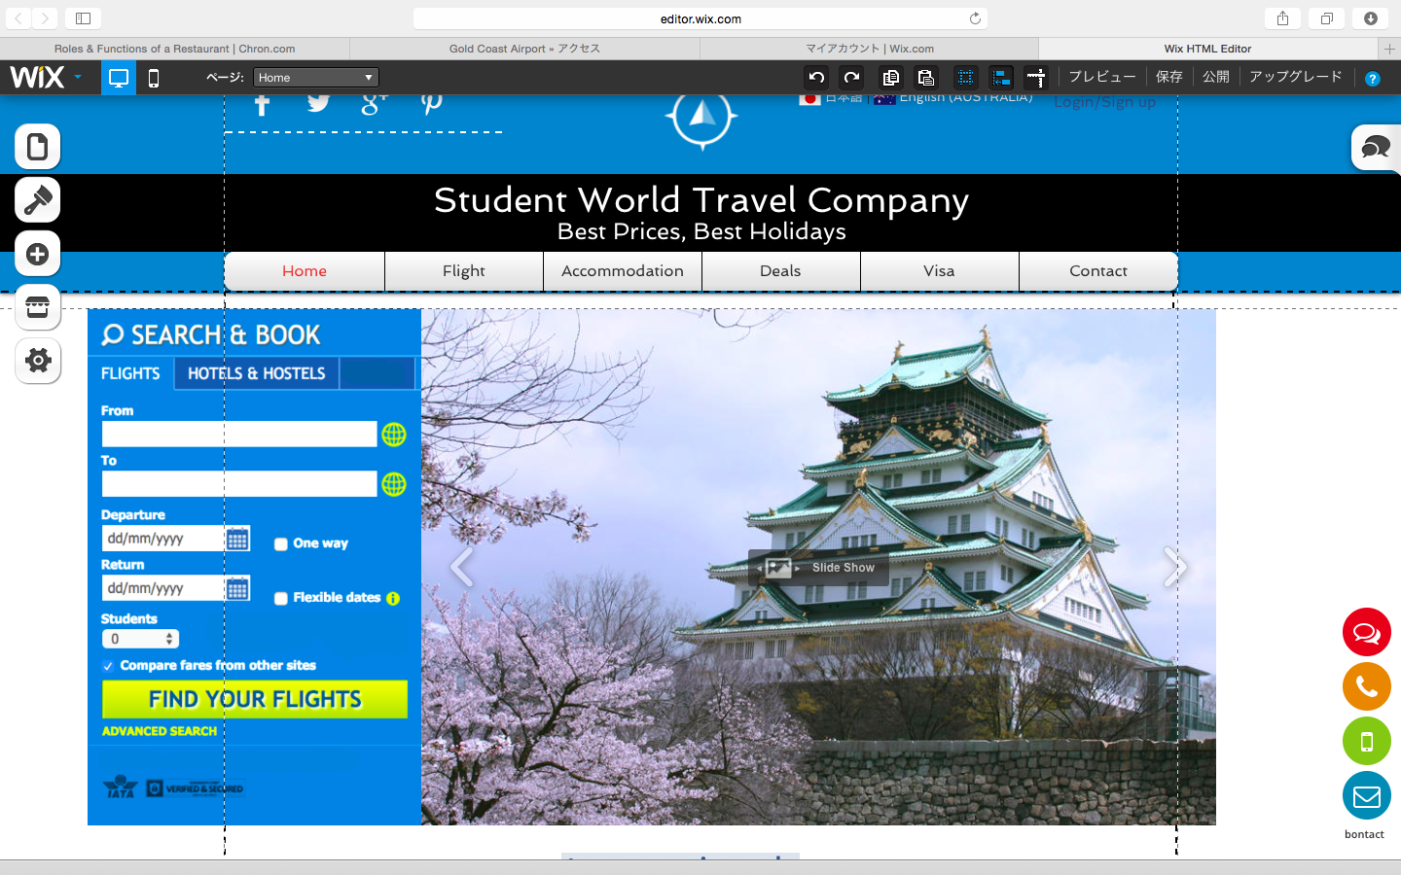

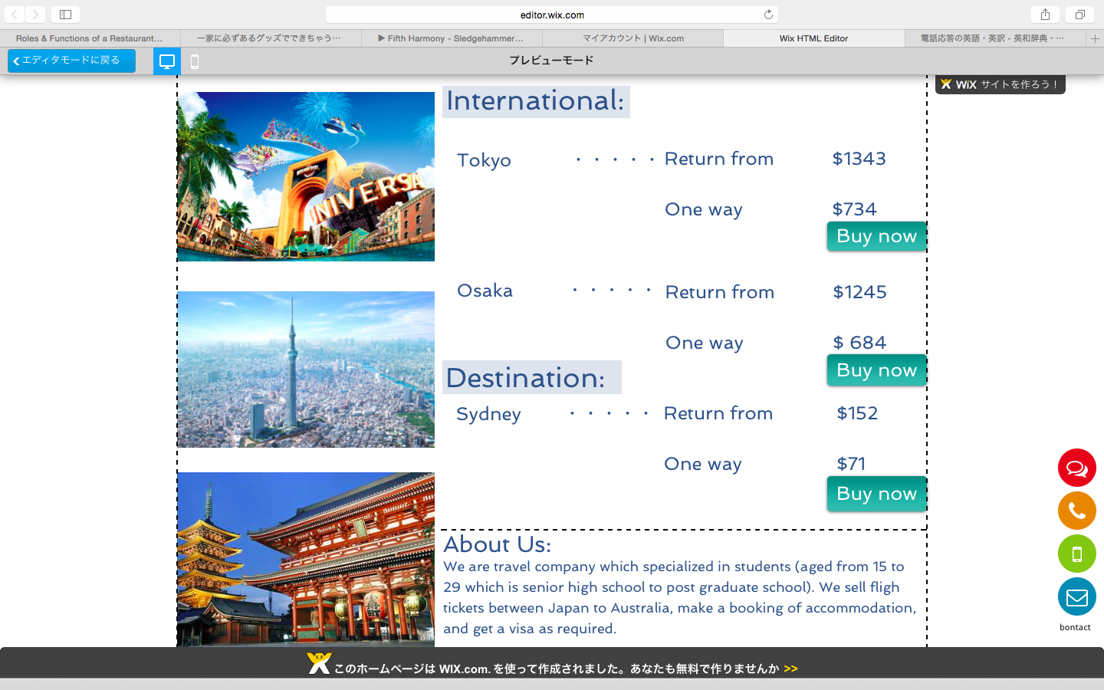
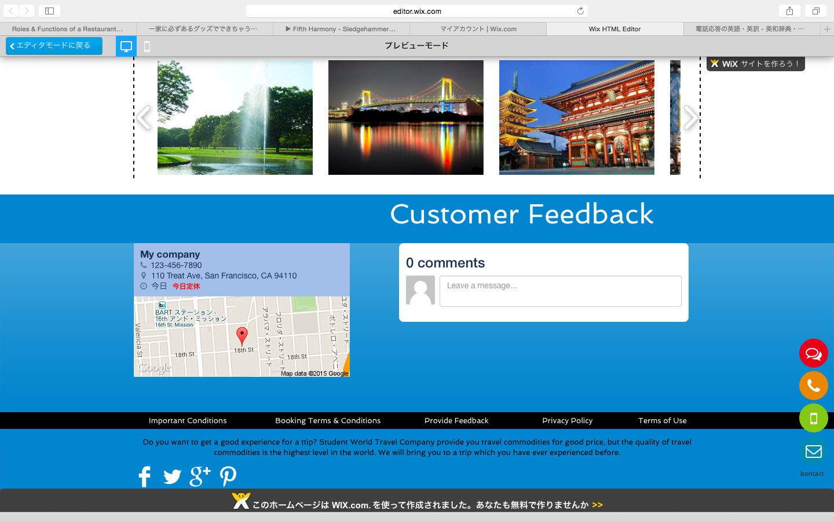

Accommodation

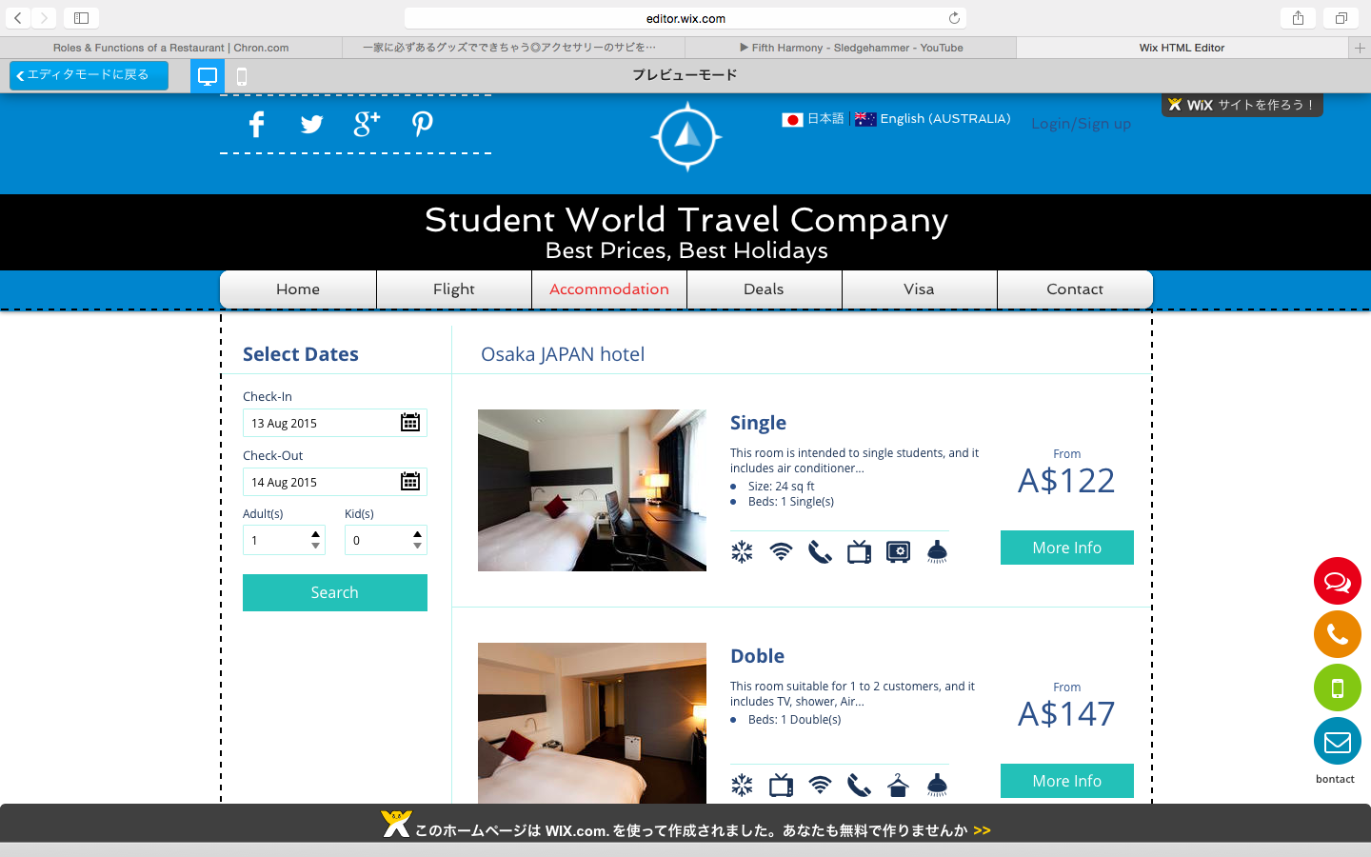

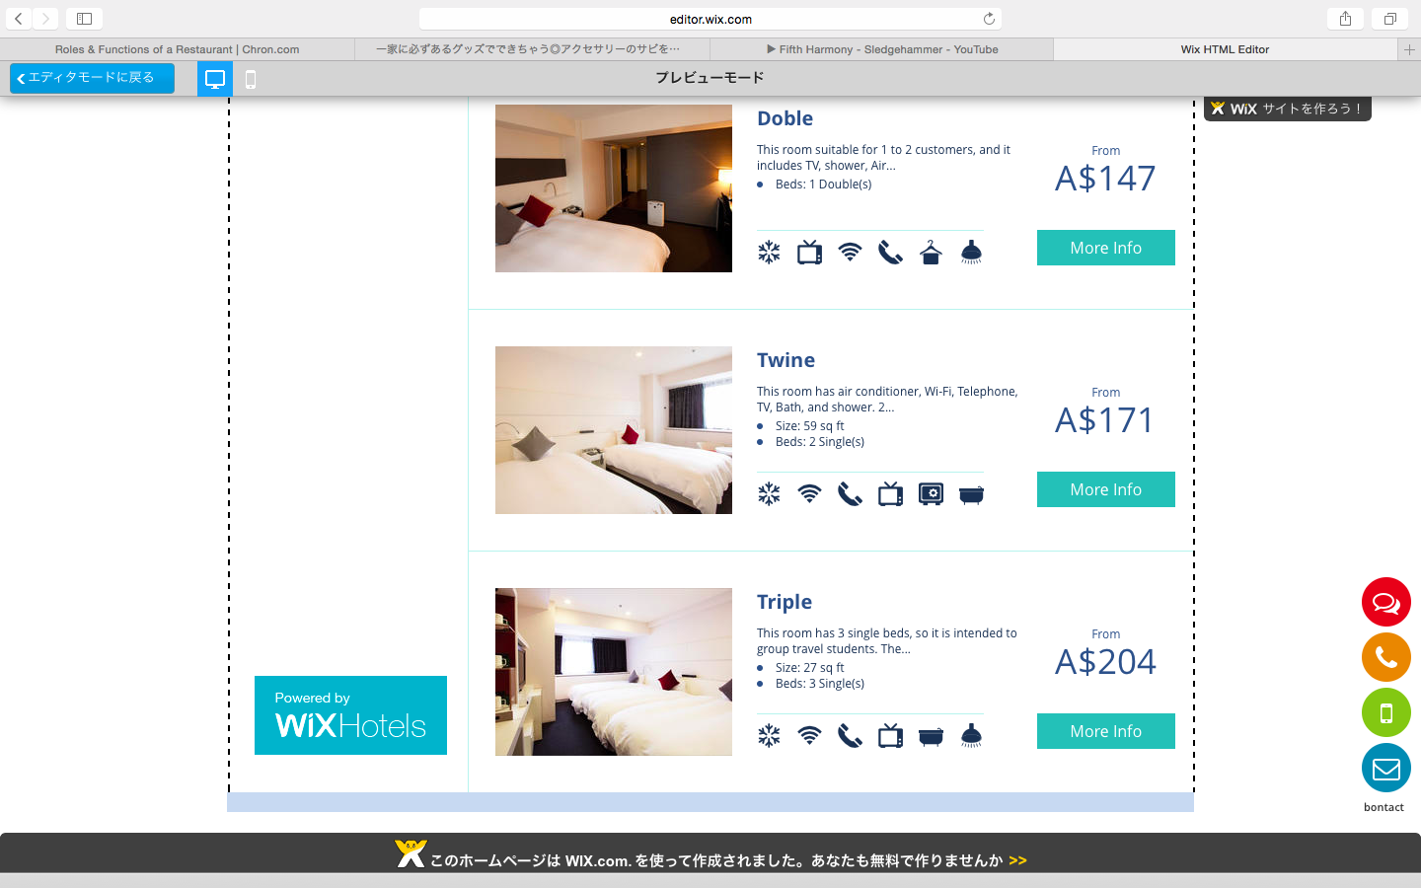

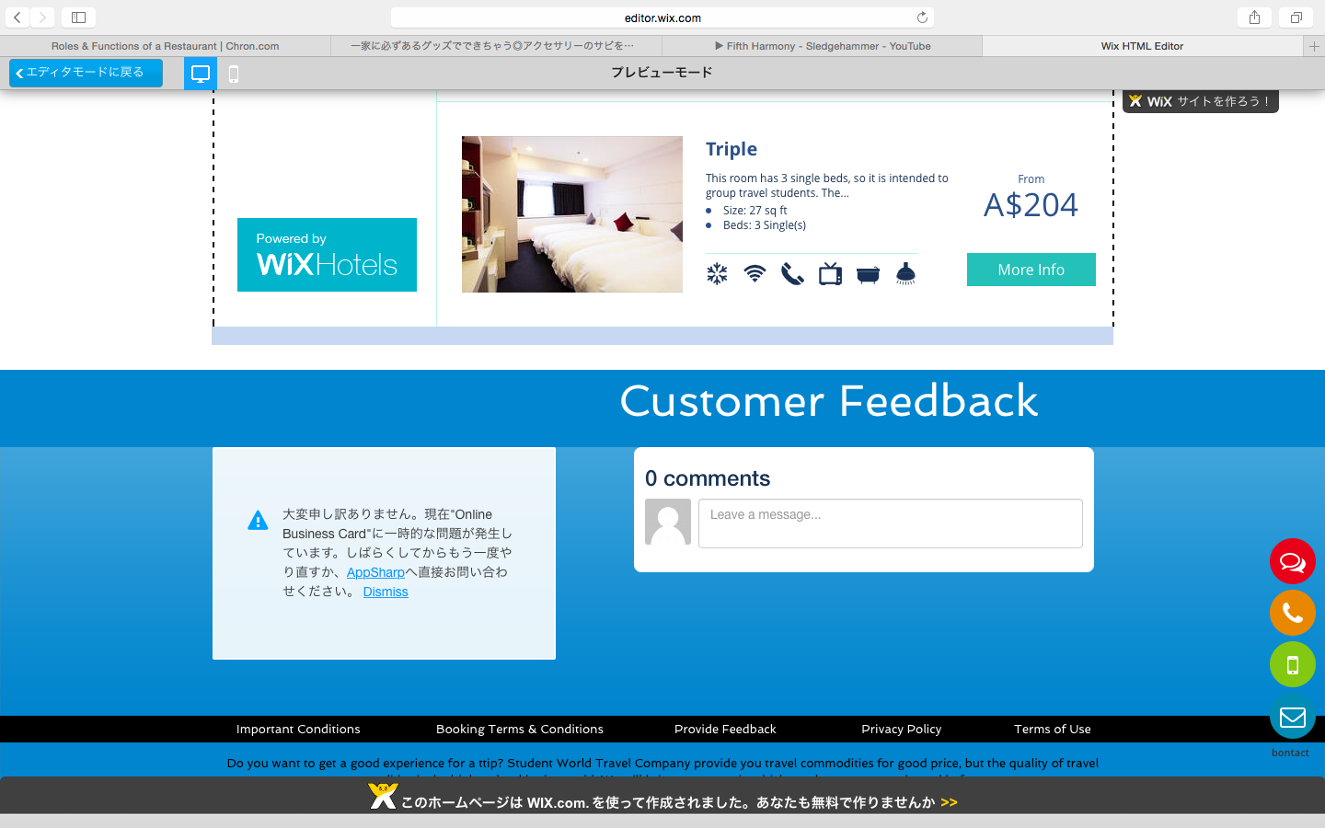

9. Process Analysis

• Communication
What | Who | How often
E-mail | A chief & Employee | Every 11 a.m.
Booking | General administrator | Every hour
Payment | General administrator | Every 11 a.m.
Feedback | Manager on duty & General administrator | Every Wednesday
Online question | Clarks | Every 11 a.m.
Table 1.3 Communication list

• Update
What content | Who | How often
Discount | Sales manager | Every month
New Flights | General administrator | Every three months
New accommodation | General administrator | Every three months
Customer feedback | A subsection chief | Every Wednesday
Table 1.4 Update list

10. Marketing Techniques
According to Ministry of Internal Affairs and Communications (2013) in Japan, the most popular social media campaigns from the teens to twenties are LINE (over70%) and the second highest social media campaigns are Twitter (over 35%). In addition, Australian Communications and Media Authority (2013) said that main social media campaign is Facebook (over 60%), so this company will use LINE and Facebook in order to attract target customers. Firstly, in regards to Japanese young people, this company will make official account on LINE, and make stamps which can get free and sell it. Secondly, in terms of Australian youth, this company will show advertisement on their pages.

This company's scale is very small, and it is very hard to be known about this company for many people, therefore this company will cooperate with other travel companies. For example, this company's advertisement will be displayed to other company's homepage, and people may be interesting about this company or remember even if it is not they are looking for. Over 60% of people searched “travel world” when they want to know about “travel” in Australia, and 45% of Japanese people searched “cheap travel” (Google Trends, 2014), so this company will add keywords” travel world” and “cheap travel” for meta tags, also this company contains “travel” and “world” for Domain name and Company's name. Additionally, this company will contain words which are “travel”, “world”, and “cheap” for the home page. It increases a possibility of this company's website to be shown top page of search results. To know these techniques thoroughly is very important to succeed in business.

Traditional marketing techniques such as print, broadcast, direct mail, and telephone are very useful when this company try to attract young people. According to Chan and Fang (2007), 42% of young people (aged 15 to 24) watch television 1 to 3 hours, and 34% of young people use phone 1 to 3 hours in a day. (p.249). In addition, 42% of people use watch television in order to search news and information of events (Chan & Fang, 2007, p.249). In other words, nearly half of young people use traditional marketing tools to search information, so this company will use television to tell young customers about information of product such as travel commodity by using a commercial message. It will impress young people, and increase company’s customers and profits.

11. Conclusion
As a result, this company will be published in order to make the relationship Japan-Australia stronger, and traveling is one of the most important factors to make each country’s relationship. In addition, this company allows students more easily to go each country between Japan and Australia by making flight tickets cheaper, make a booking system, and other systems that are convenient for students.

12. References

Abdollahbeigi, B., Langroudi, A. C., & Salehi, F. (2012). The impact of website information convenience on E-commerce success of companies. Procedia-Social and Behavioral Science, 57, 381-387. doi:10.1016/j.sbspro.2012.09.1201

Australian Communications and Media Authority. (2013). Aussie teens online. Retrieved from http://www.acma.gov.au/theACMA/engage-blogs/engage-blogs/Research-snapshots/Aussie-teensonline

Besbes, A., Kucukusta, D., Law, R., & Legohérel, P. (2015). Re-examining perceived usefulness and ease of use in online booking. International Journal of Contemporary Hospitality Management, 27(2), 185-198. doi:10.1108/IJCHM-09-2013-0413

Chan, K., & Fang, W. (2007). Use of the internet and traditional media among young people. Young Consumers, 8(4), 244-256. doi:10.1108/17473610710838608

Global Marketing Channel. (2012). Retrieved from https://www.globalmarketingchannel.com/information/search_share.html

Google Trends. (2014). Retrieved from https://www.google.co.jp/trends/explore#cat=0-67&q=travel&geo=AU&date=1%2F2014%2012m&cmpt=q&tz=Etc%2FGMT-10

Ministry of Internal Affairs and Communications. (2013). 平成25年 情報通信メディアの利用時間と情報行動に関する調査. Retrieved from http://www.soumu.go.jp/iicp/chousakenkyu/data/research/survey/telecom/2014/h25mediariyou_1sokuhou.pdf

Net Market Share. (August, 2014 to June 2015). Retrieved from http://marketshare.hitslink.com

Seo Channel. (n.d.). Retrieved from http://www.seo-ch.jp/country/japan/#

