1003MKT Team project3
Team Written Report
ellis


table of contents
1.0 Introduction 1
2.0 Product 1
2.1 New product idea 1
2.2 Type of product 2
2.3 Branding strategies 2
2.4 Packaging 2
2.5 Use new product development process 3
3.0 Place 3
3.1 Channel structure 3
3.2 Factors affecting channel choice 3
3.3 Levels of distribution intensity 3
3.4 Retailing 4
3.5 Benefits of retailing/ utility 4
4.0 Promotion 4
4.1 Goal of promotion 4
4.2 Promotion mix 4
4.3 Integrated marketing communication (IMC) 5
4.4 Factors affecting promotion mix 5
4.5 Push and Pull strategies 5
4.6 Type of advertising and media type 6
5.0 Price 6
5.1 Six stages of pricing 6
5.2 Pricing objectives 7
5.3 Determinants of price 7
5.4 How to set a price 7
6.0 Recommendation (Second year) 9
6.1 Develop a recommendation for your marketing mix in the second year 9
7.0 Conclusion 9
Appendices 10
Appendix A – Total Product Concept Map 10
Appendix B - Brand, Package and Product 10
Appendix C - distribution diagram 12
Appendix D - Picture of promotion idea 12
Appendix E – Table of competitor’s pricing research 15
Reference List 17

1.0 Introduction
The purpose of the report is to present the marketing campaign for Bundaberg E-Boost, a new energy drink of Bundaberg. The marketing team has 4 members, who are Jayden, Roy, Zoe and Yuki. The target market is university students in Australia and other western countries. The market position of the product is the premium and healthy energy drink for young people. There are three S.M.A.R.T. goals which are gaining 30% market share by the end of 2016, achieving 30% ROI by the end of 2016 and increasing the accessibility to 95% of universities in Australia and 25% in universities in the 30 countries that Bundaberg used to export. In this report, the 4P of Bundaberg E-Boost would be addressed and recommendation for the next year will be provided.

2.0 Product

2.1 New product idea
E-Boost has three layers that are core product, actual product and augmented product (see Appendix A). Firstly, core product represents the most important benefits that the product provides (Lim, Sharkey & Heinrichs, 2006), which is supporting health of body and assist energy levels for E-Boost. Secondly, the actual product is the tangible product that can be consumed by customers (Lim, Sharkey & Heinrichs, 2006), which is the E-Boost energy drink. Lastly, an augmented product refers to the non-physical value added to the product (Lim, Sharkey & Heinrichs, 2006). For E-Boost, there is customers’ service hotline and free delivery service for bulk order. Customers of E-Boost can enjoy all of the three layers of the products. For example, the benefit of E-Boost would attract customers and the natural fruit flavour drink would retain customers. If customers have any questions they can call toll free number for post-purchase service. These service would increase customers’ satisfaction.

2.2 Type of product
The category of product that E-Boost belongs is convenience products, which means the products is relatively inexpensive and customers would not spend long time in shopping this type of product (Eaton & Tweedle, 2012). For example, when customers are thirsty, they would go to the closest retailer to check which drink is available, then they would pick a familiar brand because it ensures quality. In this case, customers would not be interested in every detail of the product, the brand and accessibility of such product is important for customers purchase decision (Eaton & Tweedle, 2012).

2.3 Branding strategies
Branding strategy can help products position appropriately in the market (Lim, Sharkey & Heinrichs, 2006). E-boost selects a combination of individual branding and family branding. The full name of the product is Bundaberg E-Boost (see Appendix B). On the one hand, the family brand, Bundaberg, has already built good reputation in the market. Therefore, include Bundaberg in the brand can help the new product attract existing customers for the brand. On the other hand, an individual brand “E-Boost” indicates it is a unique line of Bundaberg that is specialised in energy drink.

2.4 Packaging
The 200ml package would use aluminium while the 330ml and 500ml would use plastic (see Appendix B). As stated by Rundh, (2013), there are four functions of packaging, which are protecting, promoting, facilitating convenient use and storage and facilitating recycle. The package of E-Boost can serve all of the functions because of the following reasons. Firstly, both aluminium and plastic are suitable for containing and storing energy drink and have been widely used in the industry. Secondly, the metal feeling provided by aluminium can provide a feeling of energy and cool and transparent plastic also makes the drink looks more attractive. Thirdly, the 330ml package would keep the classic shape of Bundaberg’s drink. Lastly, the 500ml package is intended to sell to the high-end market by its reusable plastic bottle. The design of the bottle makes it look very energetic and fashionable to attract more young customers.

2.5 Use new product development process
Before the product is launched, a prototype for at least five flavours of E-Boost would be designed for a laboratory test. The test would invite 30 people from different department of the company to taste the drink. As stated by Lim, Sharkey and Heinrichs (2006), laboratory test can help organisations to identify problems associate with a new product and make improvement based on the test.

3.0 Place

3.1 Channel structure
According to Lamb, Gardiner, Hair, McDaniel, and Summers (2013), channel structure means a way of delivering products to customers. Considering channel structure leads how to send products efficiently. There are four types of channel structure (see Appendix C), and this company will select retailer channel structure in order to deliver E-boost for consumers.

3.2 Factors affecting channel choice
Factors that affect deciding to use retailer channel structure are; who are potential consumer, what do they buy, where do they buy, and when do they buy. This project’s main consumers are “college students”, and they focus on to attract students who try to buy energy drinks. In terms of “where do they buy” and “ where do they buy”, Nowak and Jasionowski (2015) suggested 53% of energy drinks are purchased at a hypermarket, and they are usually drunk on a day off school (40%).

3.3 Levels of distribution intensity
Companies also have to consider levels of distribution intensity when they try to choose channel structure. Levels of intensity are separated as three levels; intensive, selective, and exclusive, and this project selects to use intensive distribution. Level of intensive distribution is to gather many types of market selling (Lamb et al., 2013). For example, if E-boost will be stocked at a supermarket or a convenient store, customers can buy it more easily. It will increase consumption of products.

3.4 Retailing
Retailing refers to “All the activities derectly related to the sale of goods and services to the ultimate consumer for personal, nonbusiness use” (Lambet al., 2013). In addition, if comapny focus on retailng, they can brush up quality of service or convenience (Maximov, & Gottschlich, 1993).

3.5 Benefits of retailing/ utility
This project will use retailers, which are recognized as intensive level of retailers. Some benefits are occurred when company use retailer; time utility, place utility, form utility, advice and personal service, and exchange efficiencies (Elliott, Rundle-Thiele & Waller, 2012,). Time utility means customers can buy products whenever they want such as vending machines. Place utility refers to products can be bought easily because they are sold at nearby customers such as a corner shop. Form utility is products are changed by based on customers’ desires or needs. Advice and personal service are providers give advice or service for customers personally. Exchange efficiencies mean providers provide many different types of products in one shop such as shoes and clothes.

4.0 Promotion

4.1 Goal of promotion
There are two goals for the promotion which are informing and persuading (Radakovic, 2014). Informing is very effective for introducing new product by a well-established brand (Radakovic, 2014), which is exactly the case of Bundaberg. Meanwhile, the promotion is also aimed at persuading target customers to choose Bundaberg E-Boost over other brands by promoting its premium natural flavours and health benefits.

4.2 Promotion mix
Promotion mix refers to strategically combining different promotional channels to reach the target market (Radakovic, 2014). Four promotion methods would be used for E-Boost which are advertising, public relations, sales promotion and direct marketing. Since the target market is university students, advertisements would be printed and handout in universities and posted on popular social-media websites (see Appendix D). Meanwhile, E-Boost would sponsor sports events in many universities to directly advertise to the target market. Moreover, sales promotion will be used in supermarket and convenience store as discount can attract young customers who would like to try new and different drinks. In addition, Bundaberg would directly promote the products using emails and websites. This method should help business to “pull” customers demand and motivate customers to seek products from retailers (Minnebo & Van Houdt, 2014).

4.3 Integrated marketing communication (IMC)
IMC means the information delivered through different promotional channel should be consistent and integrate instead of conflicting with each other (Radakovic, 2014). The consistent message that E-Boost trying to deliver is that the drink can not only assist energy level, but has a fun culture and encourage healthy life style for young people.

4.4 Factors affecting promotion mix
There are several factors affecting the chosen promotion mix. Firstly, the nature of E-Boost is a consumer product, which is not custom-made, thus needs advertising efforts to sell the product (Haughton et al, 2015). Secondly, E-Boost is in the introducing stage and sales promotions would encourage people to try this product. Thirdly, the target market is university students and the Bundaberg has built reputation among them by other soft drinks. Therefore, advertising and sales promotion is suitable for encouraging repeat purchase (Haughton et al, 2015). Fourthly, a soft-drink is usually purchased with routine decision, in which advertising and sales promotion is more effective than others. Lastly, sales promotion and advertising can be very cost-effective considering the cost for contact each potential customer.

4.5 Push and Pull strategies
Both push and pull strategy would be used. On the one hand, the company would negotiate with retailers to stock this new product by offering discount for bulk order (Minnebo & Van Houdt, 2014). The push strategy would help E-Boost to enter the market. On the other hand, E-Boost would also use a pull strategy, which means it would use advertising and public relations to promote the product directly to the target market and let customer seek the products from the retailers (Minnebo & Van Houdt, 2014). Pull strategy can help E-boost improve brand awareness.

4.6 Type of advertising and media type
E-Boost would use product advertising, which promotes a specific product instead of a general brand. More specifically, pioneering advertising would be used to introduce the benefits of E-Boost and in-depth information about how the drink is brewed.
Magazines and internet would be selected as the major media type for advertising. According to Cowburn & Boxer (2007), the benefit of using magazine is that the audience has been already selected. E-Boost would advertise on the sports magazines like Inside Sport and universities’ own magazines to reach the target market. Meanwhile, university students and young people like to use social media every day in their life (Cowburn & Boxer, 2007). Therefore, advertising on famous social media including Facebook and Instagram with pictures of young people sharing the drink would be very efficient (see Appendix D).

5.0 Price

5.1 Six stages of pricing
In the table below, there are six steps for setting a rational price.
<Table 1- Six steps to set a right price>
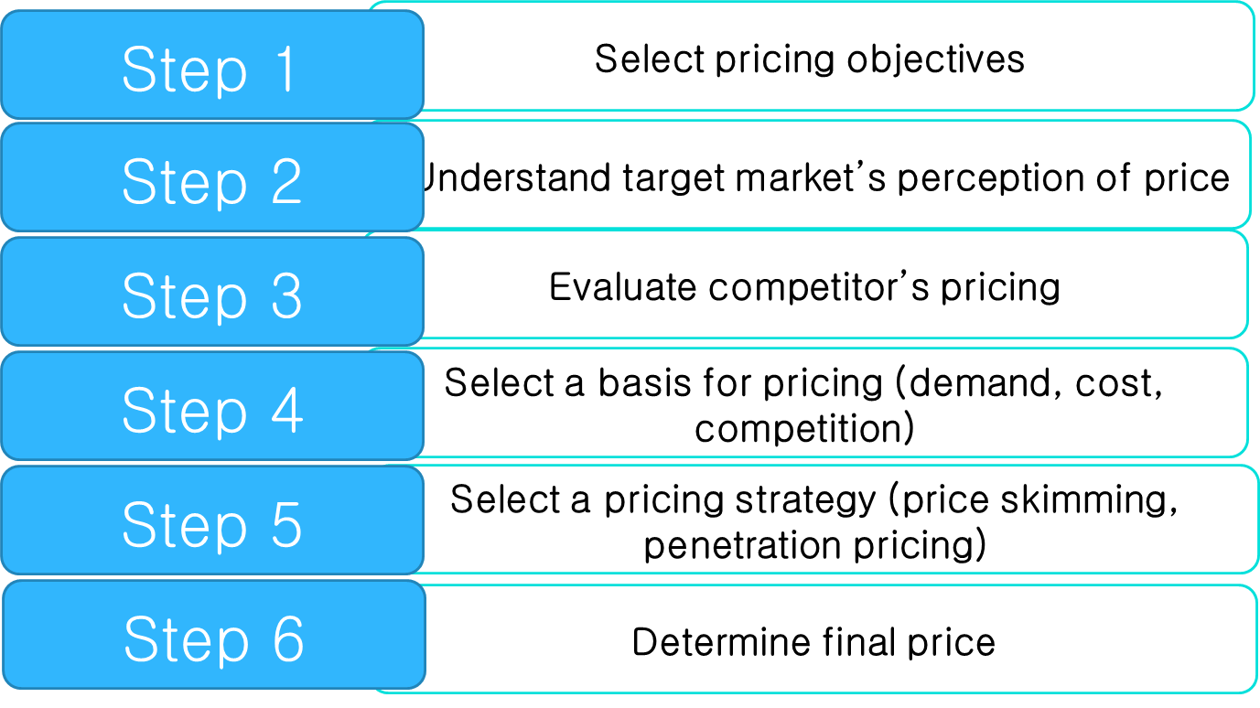
(Elliott, G., Rundle-Thiele, S., & Waller, D., 2012, Milton, Queensland: John Wiley & Sons Australia Ltd)
Our new product’s pricing objectives are to obtain reasonable and logical income. From our target market that is university student from 18 to 24 ages for both sex, it is predictable that they cannot afford to spend a lot of money on energy drinks often so it will be set the price lower compare to the other competitor’s pricing. The reason for it is possible to set a lower price is it has been chosen to use reusable materials of package of the E-boost. Furthermore, the penetration pricing strategy will be used to extend turnover and market share. The final price for E-boost will 3.00 dollars per 250ml, 4.00 dollars per 330ml and 5.00 dollars per 500ml.

5.2 Pricing objectives
There are three types of pricing objectives which are profit-oriented, sales-oriented and status quo. For the E-Boost, the market share in sales-oriented will be used because it can be a criterion how the marketing mix is applied appropriately in the mass marketplace. Also many businesses with low market share survive and even prosper so there is less risk.

5.3 Determinants of price
Marketplace of the energy drink in which there are already a lot of competitors such as V Guarana, Red Bull, Rockstar, and Mother so it is suggested to analyze the competition. The reason for that is changes in competitor prices have the potential to change revenues by shifting customers among re-tailers (Volpe & Risch & Boland, 2015). On the other hand, Intense competition can sometimes lead to price war and it often begin when one company offers a ‘sale’ (Lamb, C,W & Hair, J, F & McDaniel, C & Summers, J & Gardiner, M , 2013). That means both of the competitions cannot reach the break-even point or will head towards insolvency during that situation.

5.4 How to set a price
- Establish pricing goals
The pricing goal of E-Boost is to have a high percentage of the market share using sales-oriented.
- Estimate demand, costs and profits
Each price leads to different demand respectively. It means demand varies depending on the price. The relationship between price and demand is usually determined by the demand curve. When the price is higher, demand is reduced. However, the relationship of price and demand for each product varies depending on the price sensitivity.
- Choose a price strategy to help determine a base price
-Penetration pricing
The price strategy sets a competitive price in a specific market segment, based on a well-defined positioning strategy and penetration pricing will be used to expand its sales and market share within a short period of time.
- Fine-tune the base with pricing tactics
-Odd-even pricing
-Price bundling
For special pricing tactics that are Odd-even pricing and price bundling will be used to let customers to buy more and more E-Boost. It is proven that even number can make buyer thinks a product for even number has a better quality and it is worthy to pay for it. Also, when some product is bundled, a consumer thinks that is much cheaper and strongly wants to buy it (Lamb & Hair & Mcdaniel &Summers and Gardiner, 2013).
Appendix E shows the final version of the E-Boost’s price; compare to the other competitors’ price research. It will sell for 3.00 dollars for 250ml, 4.00 dollars for 330ml, and 5.00 dollars for 500ml by the piece. It is based on Even-pricing that is used to denote quality. There is only one package with 500ml of E-Boost and our target market can get a discount for it; selling price are12.00 dollars for Four 500ml.

6.0 Recommendation (Second year)

6.1 Develop a recommendation for your marketing mix in the second year
After 2 years, in order to increase profits, this company will improve marketing mix. This company will increase amount of production, reduce a price 5%, stock our products for restaurants, and using direct marketing to attract customers.

7.0 Conclusion
In conclusion, the benefit of the E-Boost is that environmental-friendly materials will be used for packaging and it allows to use a quick-returns policy using the reusable materials which are recovery cost. The aim of intensive distribution and giving a promotion is to achieve mass market selling and to persuade customers to buy E-Boost. To sum up, it is highly recommended to utilize a direct marketing in which techniques used to get consumers to make a purchase from their home, office or other nonretail setting.

Appendices

Appendix A – Total Product Concept Map
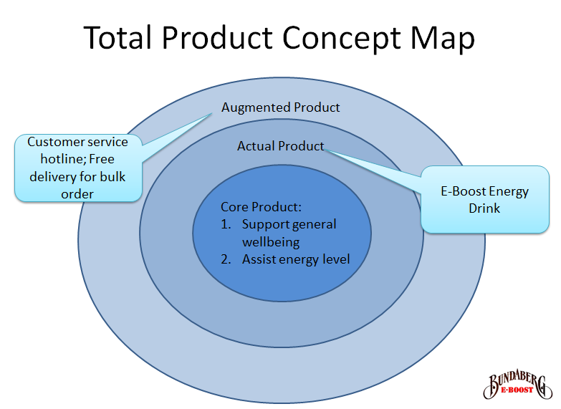

Appendix B - Brand, Package and Product

1. Brand

2. 200ml aluminium can


3. 330ml plastic bottle
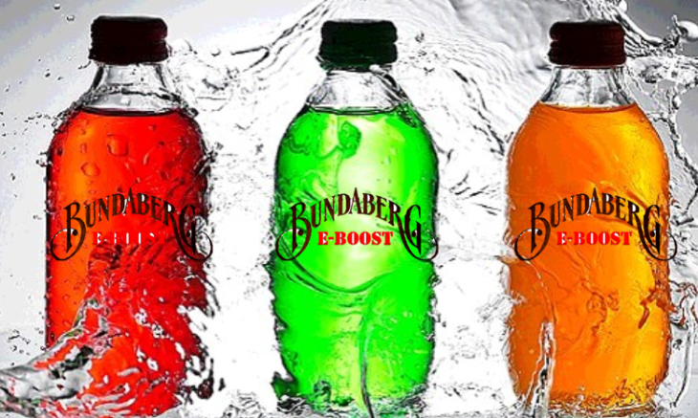
4. 500ml reusable bottle
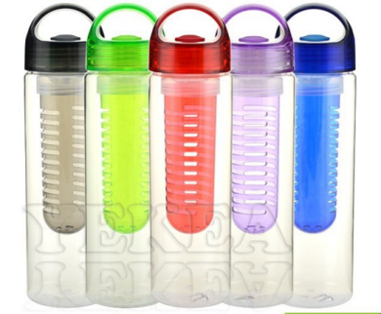

Appendix C - distribution diagram

(Lamb, Gardiner, Hair, McDaniel, & Summers, 2013, p. 138)

Appendix D - Picture of promotion idea
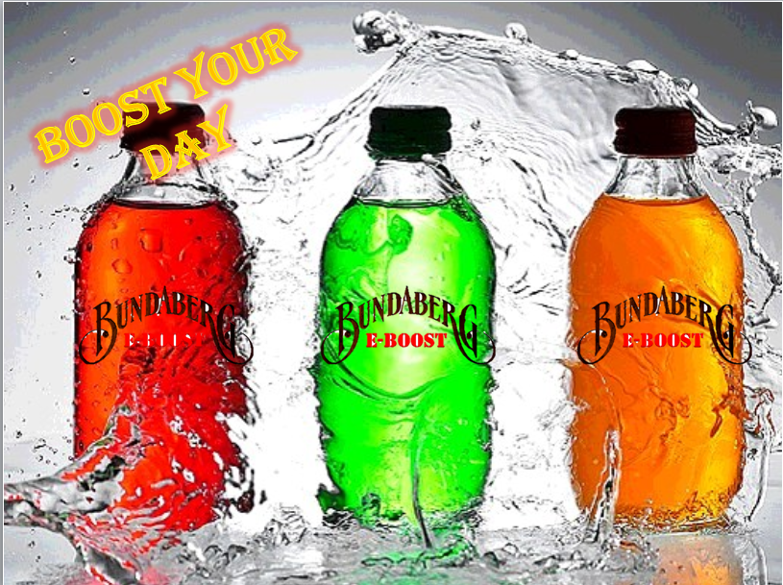
1. Printed advertisement on magazines and broachers

2. Official face book pages: https://www.facebook.com/eboost.bundaberg
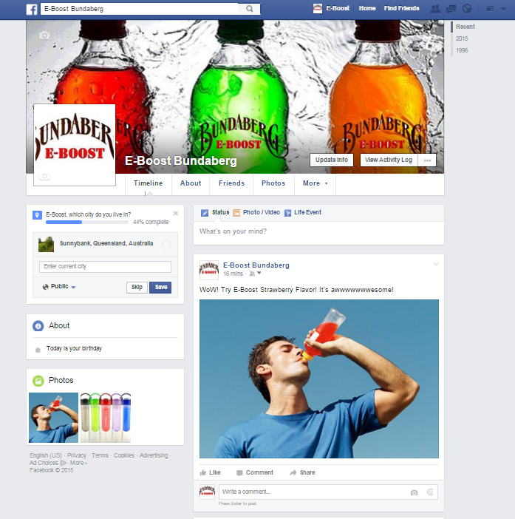

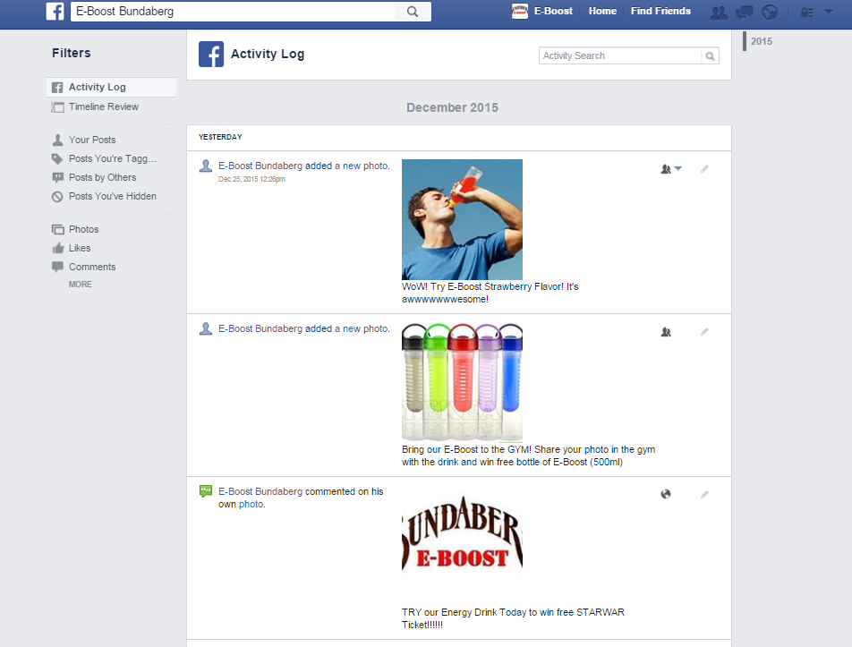
3. Promotional activities on webpage

Appendix E – Table of competitor’s pricing research
V Guarana | Red Bull | Rockstar | Mother | E-Boost
List price  250ml for $3.90  350ml for $4.80  500ml for $5.40 | List price  250ml for $3.80  355ml for $4.70  473ml for $5.20 | List price  500ml for $4.25 | List price  250ml for $3.50 | List price  250ml for $3.00  330ml for $4.00  500ml for $5.00
online malls(Woolworths)  250ml for $2.69  500ml for $3.45 | online malls  250ml for $2.75  355ml for $3.69 | online malls  X | online malls  250ml for $2.60 | online malls  500ml for $ 3.99
By the bundle  4x500ml for $11.69 | By the bundle  4x250ml for $9.99  4x355ml for $13.50 | By the bundle  X | By the bundle  2 x 250ml for $ 5 | By the bundle  4x500ml for $12.00

Reference List

Cowburn, G., & Boxer, A. (2007). Magazines for children and young people and the links to internet food marketing: A review of the extent and type of food advertising. Public Health Nutrition, 10(10), 1024-31. doi:http://dx.doi.org/10.1017/S1368980007666658

Eaton, B. C., & Tweedle, J. (2012). A hotelling style model of spatial competition for a convenience good. The Annals of Regional Science, 49(2), 447-469. doi:http://dx.doi.org/10.1007/s00168-011-0458-0

Haughton, D., Hua, G., Jin, D., Lin, J., Wei, Q., & Zhang, C. (2015). Optimization of the promotion mix in the healthcare industry. International Journal of Pharmaceutical and Healthcare Marketing, 9(4), 289-305.

Lamb, C. W., Gardiner, M., Hair, J. F., McDaniel, C., & Summers, J. (2013). mktg2 (2nd Asia-Pacificition. ed.). South Melbourne, Victoria: Cengage Learning.

Lim, J-S., Sharkey, T. W., & Heinrichs, J. H. (2006). Strategic impact of new product development on export involvement.European Journal of Marketing, 40(1), 44-60.

  - Maximov, J., & Gottschlich, H. (1993). time-cost-quality leadership: New ways to gain a sustainable competitive advantage in retailing. International Journal of Retail & Distribution Management, 21(4), 3. doi:10.1108/09590559310040442

Minnebo, W., & Van Houdt, B. (2014). A fair comparison of pull and push strategies in large distributed networks. IEEE/ACM Transactions on Networking, 22(3), 996-1006. doi:http://dx.doi.org/10.1109/TNET.2013.2270445

  - Nowak, D., & Jasionowski, A. (2015). Analysis of the consumption of caffeinated energy drinks among polish adolescents. International Journal of Environmental Research and Public Health, 12(7), 7910-7921. doi:10.3390/ijerph120707910

Radakovic, K. (2014). Advertising and promotion: an integrated marketing communications perspective. Ekonomski Horizonti, 16(3), 257-259. doi:http://dx.doi.org/10.5937/ekonhor1403265R

Rundh, B. (2013). Linking packaging to marketing: How packaging is influencing the marketing strategy. British Food Journal,115(11), 1547-1563. doi:http://dx.doi.org/10.1108/BFJ-12-2011-0297

Volpe, R & Risch, C & Boland, M (2015). The Determinants of Price Adjustments in Retail Supermarkets. MANAGERIAL AND DECISION ECONOMICS. doi:10.1002/mde.2737

- Waller, D., Rundle-Thiele, S., & Elliott, G. (2013). Marketing (2nd edition) John Wiley & Sons, Incorporated.

